3GPP TSG RAN WG2 #71 R2-104662
23rd – 27th Aug, Madrid, Spain

Source: ZTE
Title: MTC simulation results with specific solutions
Agenda Item: 4.3.2.2
Document for: Discussion

Introduction
This paper provides simulation results for different MTC-specific RACH overload solutions, namely:
- BO based schemes (Section 2.1)
- ACB based schemes (Section 2.2)
- Separate RACH resources (Section 2.3)
- Dynamic allocation of RACH resources (Section 2.4)
Most of the approaches have only been applied to LTE, only for ‘Separate RACH resources’ UMTS has been considered as well.
Based on the simulation results benefits and drawbacks of these solutions are also analyzed (Section 3).

Simulation results
The simulation parameters and assumptions are the same as defined in the contributions evaluating the current MTC performance for LTE [1] and UMTS [2]. Specific simulation parameters and methods for each solution are listed in each corresponding section.

BO based scheme
This approach has been considered for LTE only.
In this case, the backoff for Normal UEs is fixed to 20ms. In order to evaluate MTC performance when using different backoff values, the following cases have been simulated:
- MTC specific Back off time = 80ms, 240ms, 960ms
(Normal UE back off time is fixed to 20ms)

RACH performance

MTC RA attempts randomization period: 10 seconds
Table 2.1-1 shows the results for the 10s case:
 | MTC Backoff = 80ms | MTC Backoff = 240 ms | MTC Backoff = 960 ms
Collision rate | 52.37% | 52.76% | 44.92%
MTC Access Success probability | 12.29% | 15.56% | 28.66%
UE Access Success probability | 50% | 55.71% | 65.71%
Table 2.1-1. RACH performance (10 seconds spreading time)

Figures 2.1-1 and 2.1-2 show the CDF of access delay of MDs (MTC Devices) and UEs:
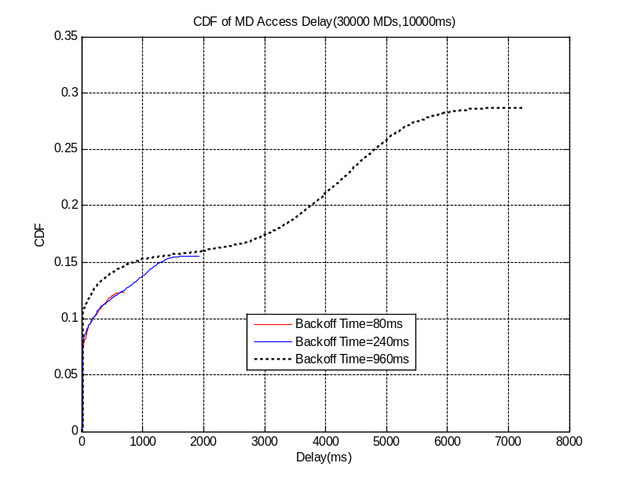
Figure 2.1-1 CDF of access delay - 10s case (MTC)
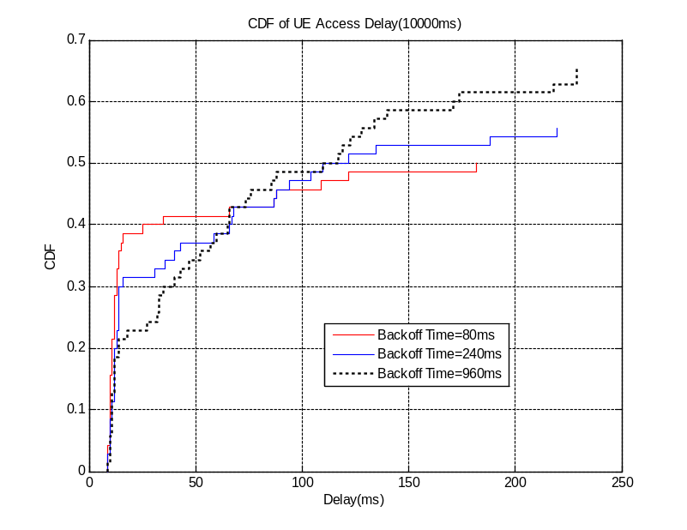
Figure 2.1-2 CDF of access delay - 10s case (Normal UE)

MTC RA attempts randomization period: 60 seconds
Table 2.1-2 shows the results for the 60s case:
 | MTC Backoff = 80ms | MTC Backoff = 240 ms | MTC Backoff = 960 ms
Collision rate | 0.19% | 0.2% | 0.19%
MTC Access Success probability | 100% | 100% | 100%
UE Access Success probability | 100% | 100% | 100%
Table 2.1-2. RACH performance (60 seconds spreading time)

Figures 2.1-3 and 2.1-4 show The CDF of access delay of MDs (MTC Devices) and UEs:
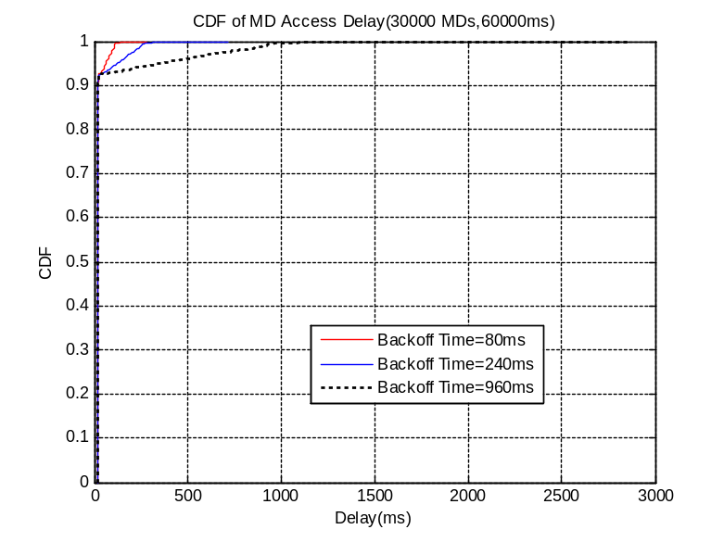
Figure 2.1-3 CDF of access delay - 60s case (MTC)
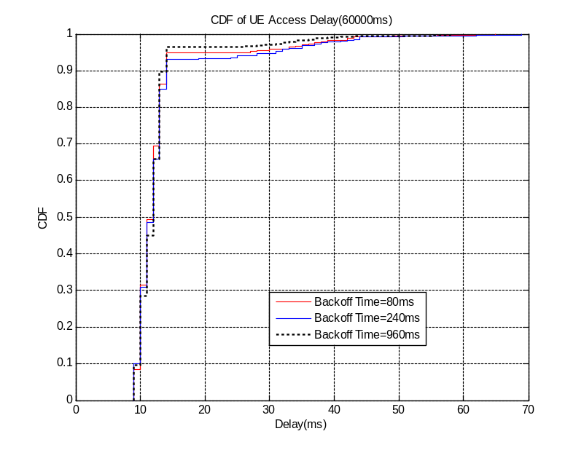
Figure 2.1-4 CDF of access delay - 60s case (Normal UE)

MTC application level performance

MTC RA attempts randomization period: 10 seconds
Two cases are simulated: high and low background traffic loads.
High traffic load: 75% of control and shared resources are used by non-MTC devices.
Low traffic load: 25% of control and shared resources are used by non-MTC devices.

Table 2.1-3 shows the results for the 10s case:
 | MTC Backoff = 80ms |  | MTC Backoff = 240 ms |  | MTC Backoff = 960 ms
 | High load | Low load | High load | Low load | High load | Low load
Collision probability | 57.30% | 56.19% | 56.37% | 56.14% | 45.73% | 44.76%
MTC Access Success probability | 3.59% | 7.99% | 4.14% | 9.47% | 7.55% | 17.46%
MTC Completion Success probability | 3.37% | 7.99% | 3.93% | 9.47% | 7.11% | 17.46%
UE Access Success probability | 54.29% | 47.14% | 56.37% | 52.86% | 57.14% | 60%
PDCCH Usage | 13.44% | 27.60% | 14.45% | 31.80% | 16.63% | 39.16%
PDSCH Usage | 3.71% | 8.50% | 4.21% | 10.20% | 5.55% | 13.35%
PUSCH Usage | 21.46% | 40.16% | 22.09% | 43.62 | 21.86% | 47.10%
Table 2.1-3. Application performance (10 seconds spreading time)

The following Figures show the CDF of application delay of MDs (MTC Devices) and access delay of UEs:
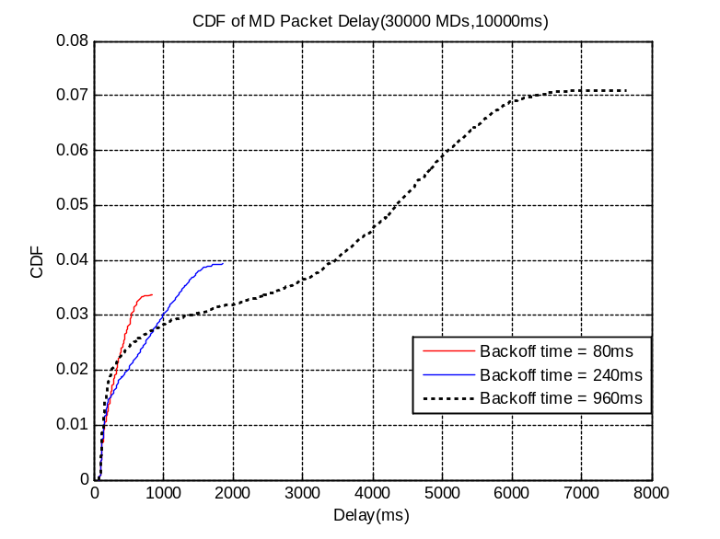
Figure 2.1-5 CDF of application delay - 10s case with high load (MTC)
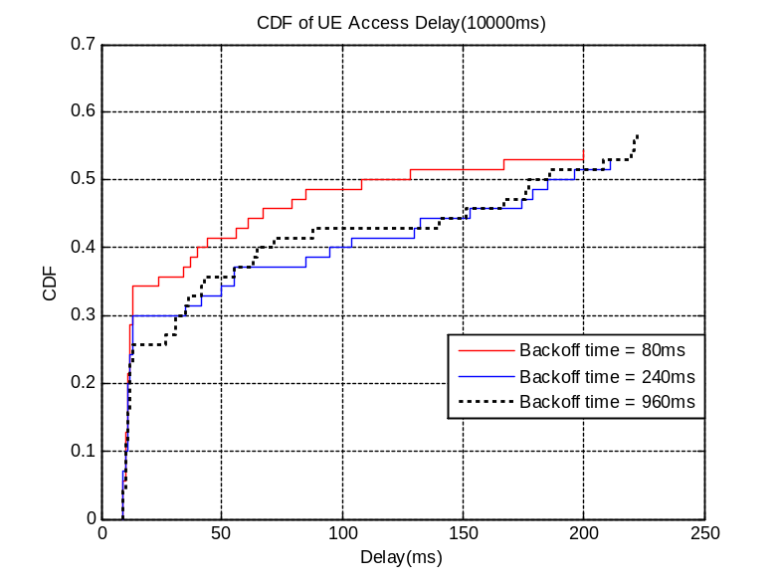
Figure 2.1-6 CDF of access delay - 10s case with high load (UE)
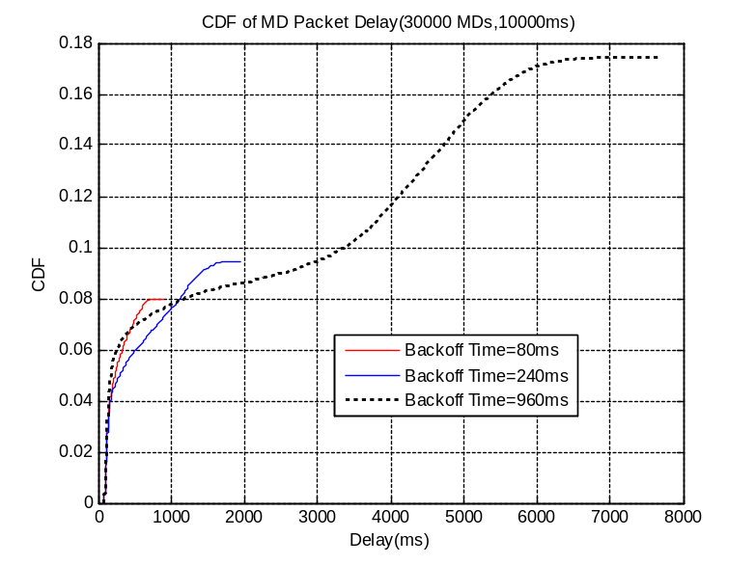
Figure 2.1-7 CDF of application delay - 10s case with low load (MTC)
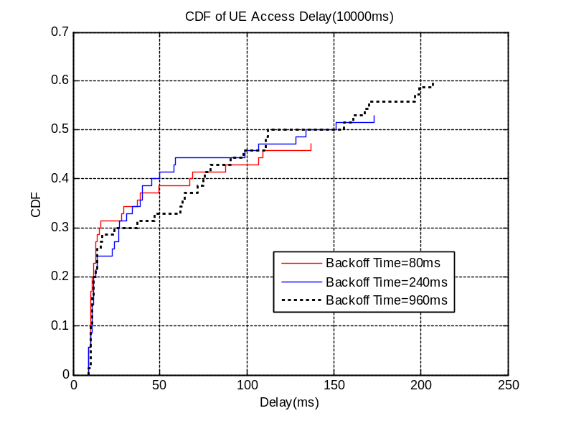
Figure 2.1-8 CDF of access delay - 10s case with low load (UE)

MTC RA attempts randomization period: 60 seconds
Table 2.1-4 shows the results for the 60s case:
 | MTC Backoff = 80ms |  | MTC Backoff = 240 ms |  | MTC Backoff = 960 ms
 | High load | Low load | High load | Low load | High load | Low load
Collision probability | 7.75% | 2.28% | 7.53% | 2.18% | 7.44% | 1.83%
MTC Access Success probability | 40.38% | 89.95% | 40.72% | 90.77% | 42.40% | 93.47%
MTC Completion Success probability | 37.79% | 89.95% | 38.09% | 90.77% | 39.11% | 93.47%
UE Access Success probability | 100% | 100% | 100% | 100% | 100% | 100%
PDCCH Usage | 16.99% | 41.62% | 17.11% | 41.89% | 17.71% | 43.03%
PDSCH Usage | 7.07% | 16.10% | 7.10% | 16.20% | 7.37% | 16.64%
PUSCH Usage | 16.13% | 35.34% | 16.26% | 35.58% | 16.80% | 36.17%
Table 2.1-4. Application performance (60 seconds spreading time)

The following Figures the CDF of application delay of MDs (MTC Devices) and access delay of UEs:
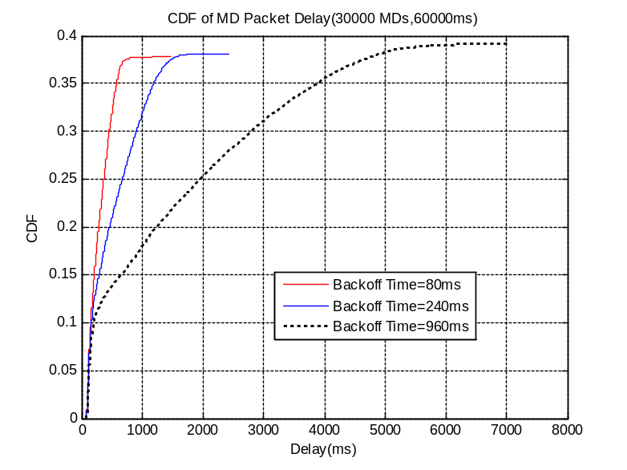
Figure 1-9 CDF of application delay - 60s case with high load (MTC)
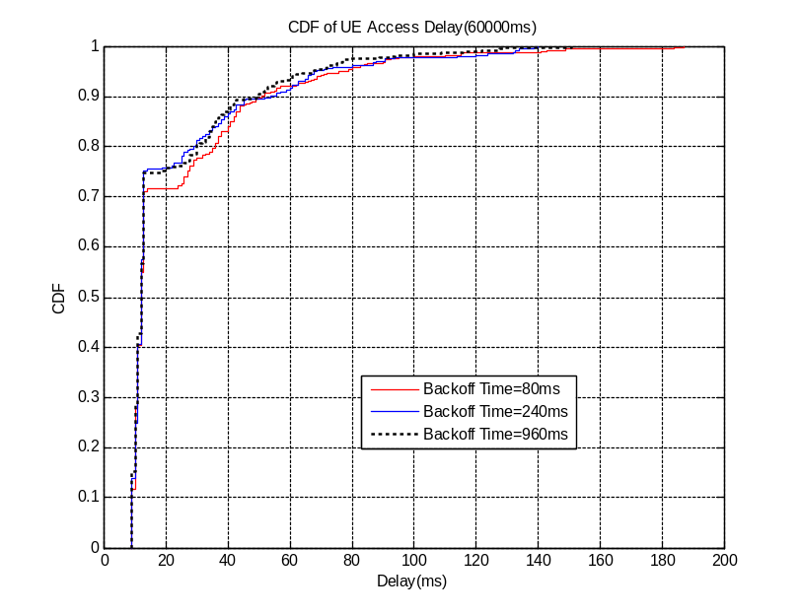
Figure 1-10 CDF of access delay - 60s case with high load (UE)

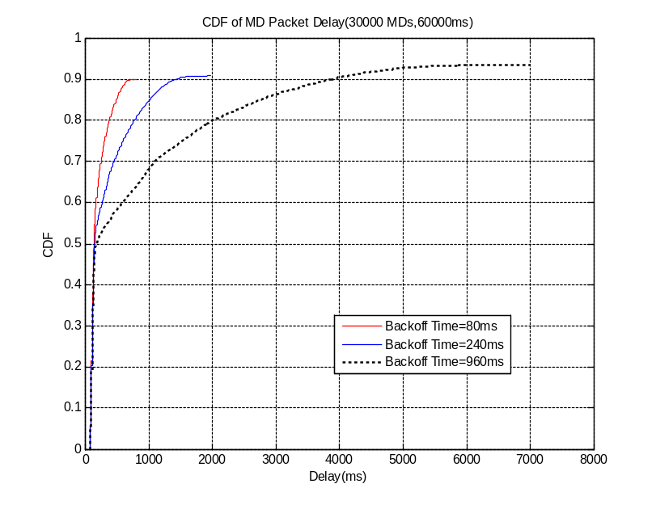
Figure 1-11 CDF of application delay - 60s case with low load (MTC)

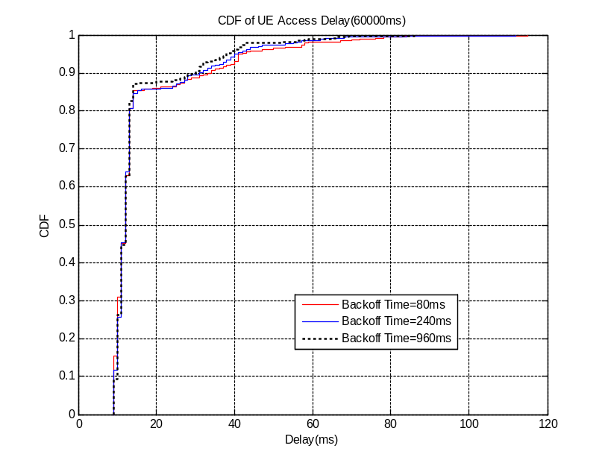
Figure 1-12 CDF of access delay - 60s case with low load (UE)

ACB based scheme
This approach has been considered for LTE only.
In this case, the barring factor for Normal UEs is always 1. 3 parameter settings are simulated for MTC devices:
- MTC ACB factor = 0.9, ACB time = 4
- MTC ACB factor = 0.7, ACB time = 8
- MTC ACB factor = 0.5, ACB time = 16

RACH performance

MTC RA attempts randomization period: 10 seconds
Table 2.2-1 shows the results for the 10s case:
 | MTC ACB factor = 0.9  ACB time = 4 | MTC ACB factor = 0.7  ACB time = 8 | MTC ACB factor = 0.5  ACB time = 16
Collision rate | 23.17% | 5.87% | 1.07%
MTC Access Success probability | 17.41% | 44.95% | 68.98%
UE Access Success probability | 40% | 50% | 64.29%
Table 2.2-1. RACH performance (10 seconds spreading time)

Figures 2.2-1 and 2.2-2 show the CDF of access delay of MDs(MTC Devices) and UEs:
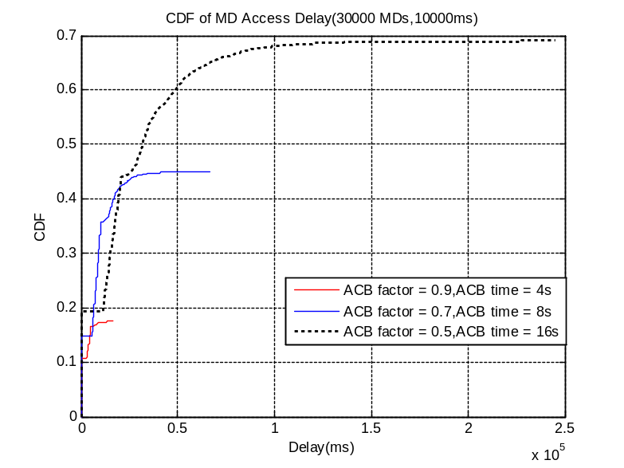
Figure 2.2-1 CDF of access delay - 10s case (MTC)

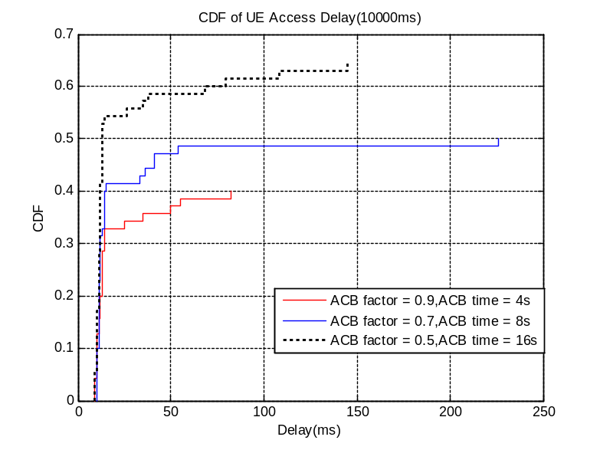
Figure 2.2-2 CDF of access delay - 10s case (UE)

MTC RA attempts randomization period: 60 seconds
Table 2.2-2 shows the results for the 60s case:
 | MTC ACB factor = 0.9  ACB time = 4 | MTC ACB factor = 0.7  ACB time = 8 | MTC ACB factor = 0.5  ACB time = 16
Collision rate | 0.19% | 0.1% | 0.02%
MTC Access Success probability | 100% | 100% | 100%
UE Access Success probability | 100% | 100% | 100%
Table 2.2-2. RACH performance (60 seconds spreading time)

Figures 2.2-3 and 2.2-4 show the CDF of access delay of MDs(MTC Devices) and UEs:
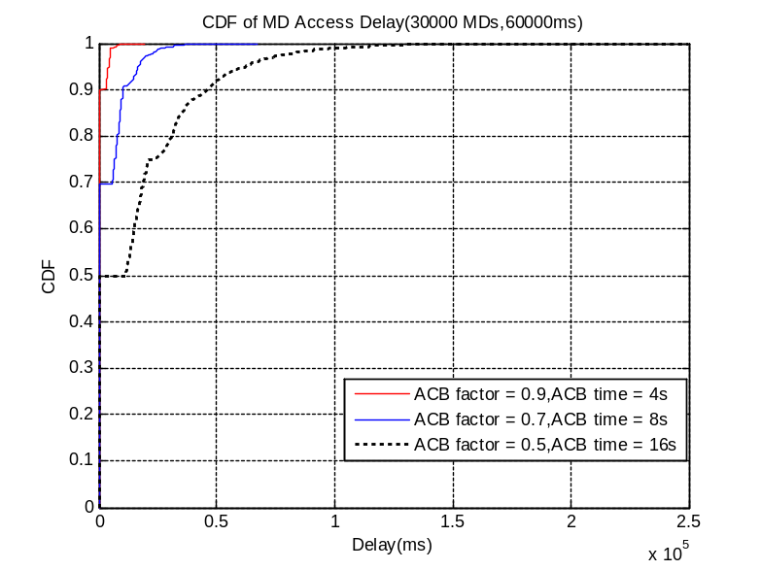
Figure 2.2-3 CDF of access delay - 60s case (MTC)

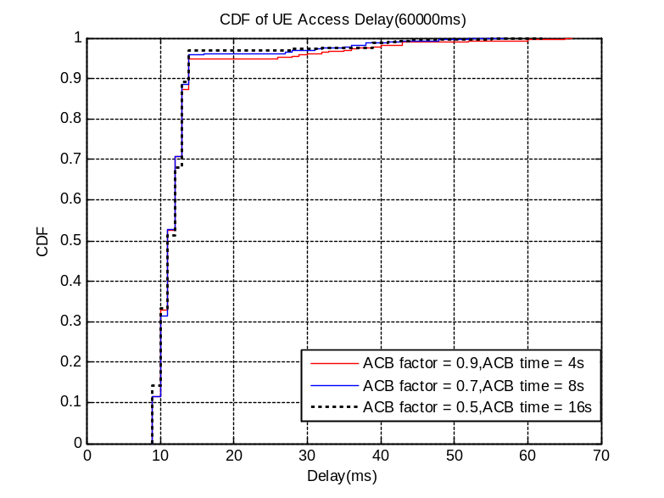
Figure 2.2-4 CDF of access delay - 60s case (UE)

MTC application level performance

MTC RA attempts randomization period: 10 seconds
Table 2.2-3 shows the results for the 10s case:
 | MTC ACB factor = 0.9  ACB time = 4 |  | MTC ACB factor = 0.7  ACB time = 8 |  | MTC ACB factor = 0.5  ACB time = 16
 | High load | Low load | High load | Low load | High load | Low load
Collision probability | 26.65% | 22.09% | 8.49% | 6.61% | 2.13% | 1.37%
MTC Access Success probability | 6.71% | 12.63% | 20.17% | 36.45% | 42.07% | 62.58%
MTC Completion Success probability | 6.37% | 12.63% | 19.44% | 36.45% | 40.68% | 62.58%
UE Access Success probability | 51.43% | 47.14% | 68.57% | 52.86% | 85.71% | 67.14%
PDCCH Usage | 9.56% | 16.27% | 7.79% | 52.86% | 4.79% | 7.48%
PDSCH Usage | 3.19% | 5.41% | 3.04% | 5.36% | 1.97% | 2.83%
PUSCH Usage | 12.91% | 20.63% | 8.27% | 14.53% | 4.71% | 6.89%
Table 2.2-3. Application performance (10 seconds spreading time)

The following Figures show the CDF of application delay of MDs (MTC Devices) and access delay of UEs:
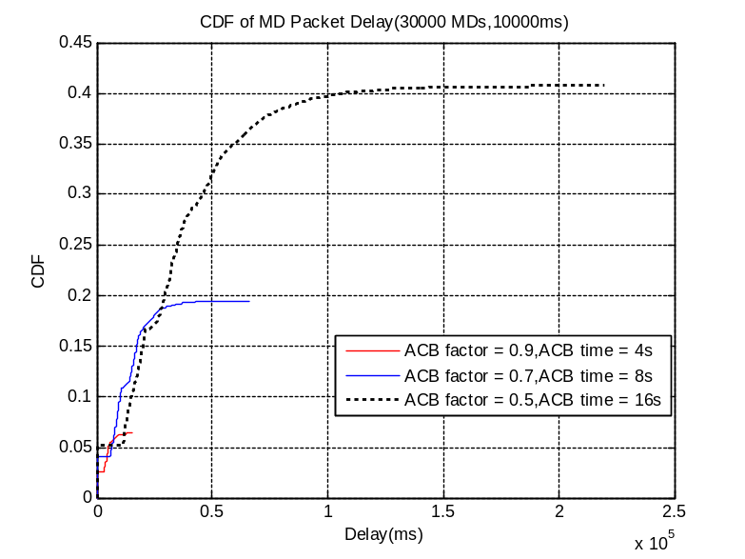
Figure 2.2-5 CDF of application delay - 10s case with high load (MTC)
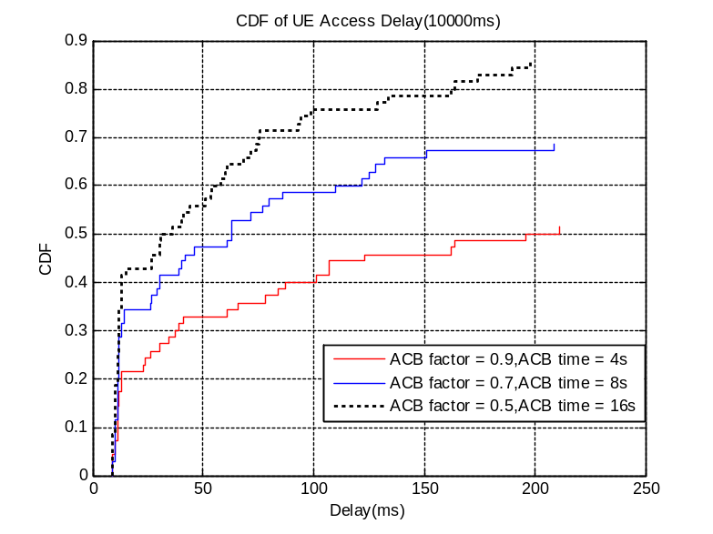
Figure 2.2-6 CDF of access delay -10s case with high load (UE)

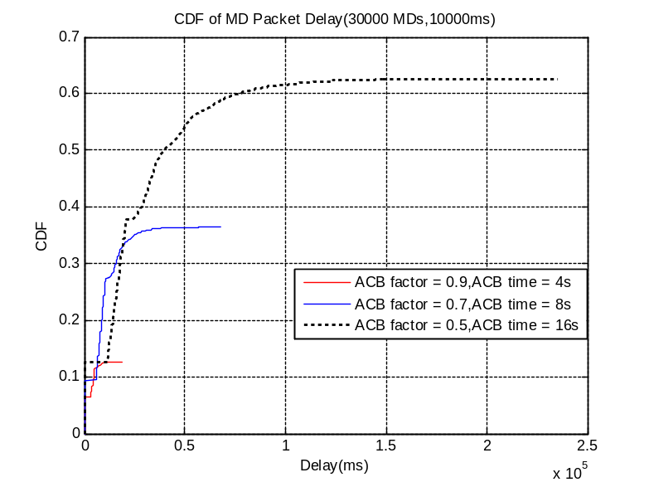
Figure 2.2-7 CDF of application delay - 10s case with low load (MTC)
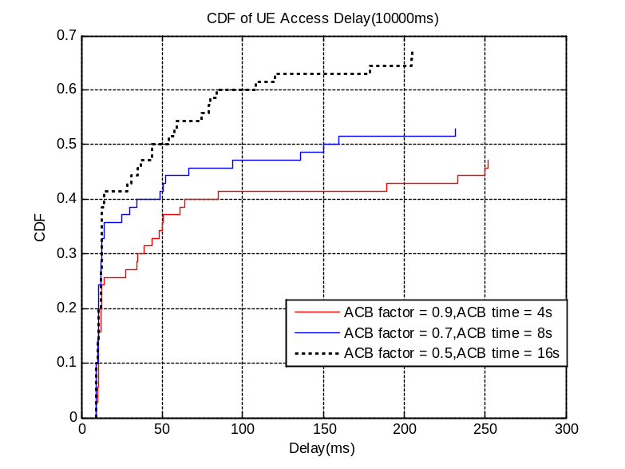
Figure 2.2-8 CDF of access delay - 10s case with low load (UE)

MTC RA attempts randomization period: 60 seconds
Table 2.2-4 shows the results for the 60s case:
 | MTC ACB factor = 0.9  ACB time = 4 |  | MTC ACB factor = 0.7  ACB time = 8 |  | MTC ACB factor = 0.5  ACB time = 16
 | High load | Low load | High load | Low load | High load | Low load
Collision probability | 8% | 2.44% | 5.24% | 0.97% | 1.21% | 0.02%
MTC Access Success probability | 39.48% | 90.22% | 45.22% | 94.47% | 67.61% | 100%
MTC Completion Success probability | 39.05% | 90.22% | 42.92% | 94.47% | 63.90% | 100%
UE Access Success probability | 99.76% | 100% | 100% | 100% | 100% | 100%
PDCCH Usage | 15.86% | 39.61% | 12.76% | 24.72% | 6.99% | 9.86%
PDSCH Usage | 6.53% | 15.31% | 5.30% | 9.56% | 2.95% | 3.81%
PUSCH Usage | 15.24% | 33.78% | 12.10% | 21.08% | 6.58% | 8.60%
Table 2.2-4. Application performance (60 seconds spreading time)

The following Figures show the CDF of application delay of MDs (MTC Devices) and access delay of UEs:
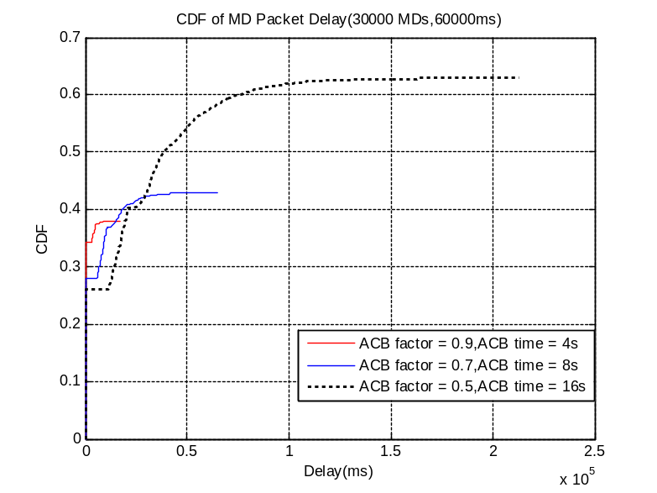
Figure 2.2-9 CDF of application delay - 60s case with high load (MTC)
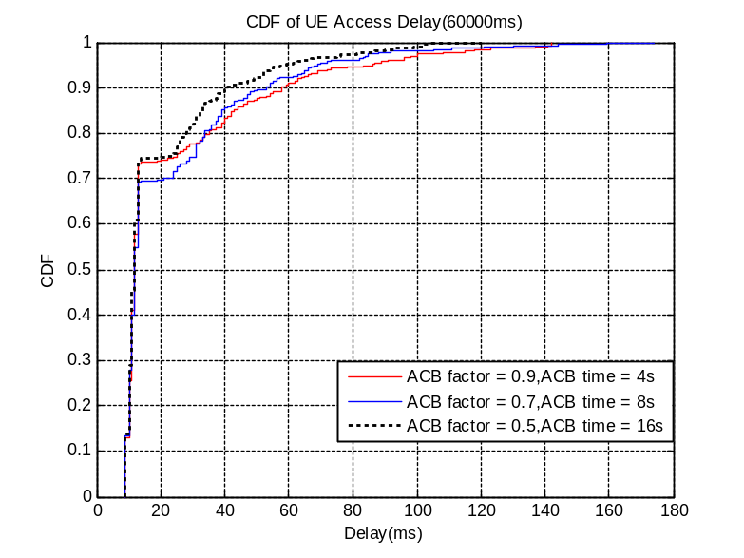
Figure 2.2-10 CDF of access delay - 60s case with high load (UE)

Figure 2.2-11 CDF of application delay - 60s case with low load (MTC)
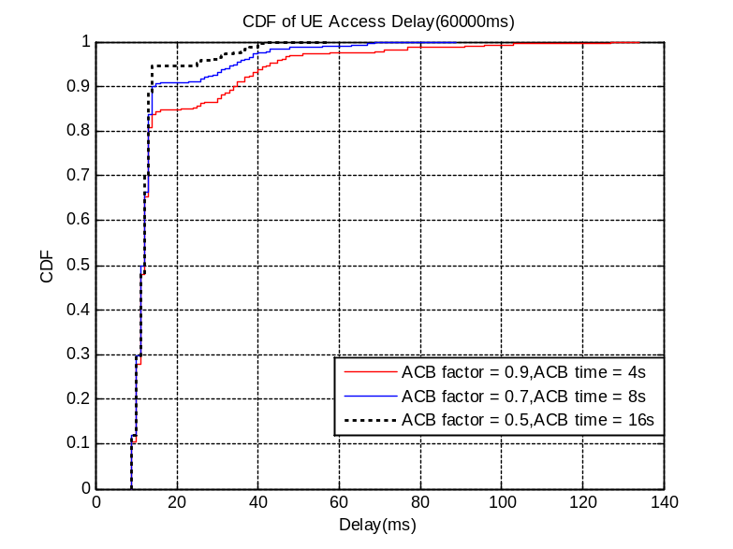
Figure 2.2-12 CDF of access delay - 60s case with low load (UE)

Separate RACH resources

LTE
In this case, 3 different partition sets are considered:
- Preamble partition for MTC/UE is 53/1
- Preamble partition for MTC/UE is 50/4
- Preamble partition for MTC/UE is 46/8
And only pure RACH with 10s randomization period is simulated.

RACH performance

MTC RA attempts randomization period: 10 seconds
Table 2.3-1 shows the results for the 10s case:
 | MTC/UE is 53/1 | MTC/UE is 50/4 | MTC/UE is 46/8
Collision rate | 51.75% | 53.68% | 55.08%
MTC Access Success probability | 11.46% | 10.21% | 10.07%
UE Access Success probability | 42.86% | 42.86% | 48.57%
Table 2.3-1. RACH performance (10 seconds spreading time)
Figures 2.3-1 and 2.3-2 show the CDF of access delay of MDs(MTC Devices) and UEs:
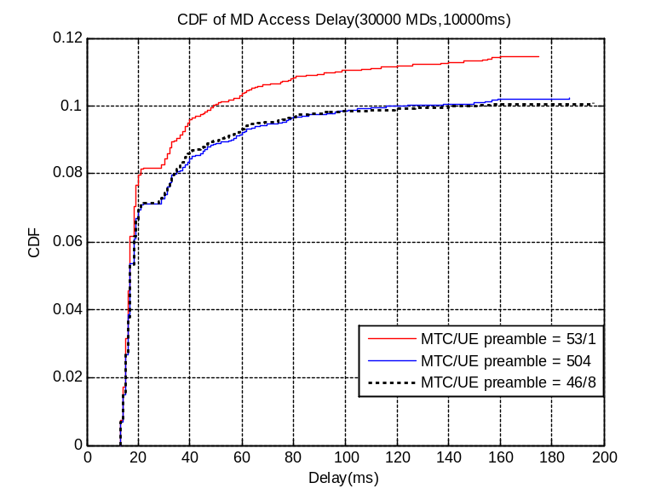
Figure 2.3-1 CDF of access delay - 10s case (MTC)
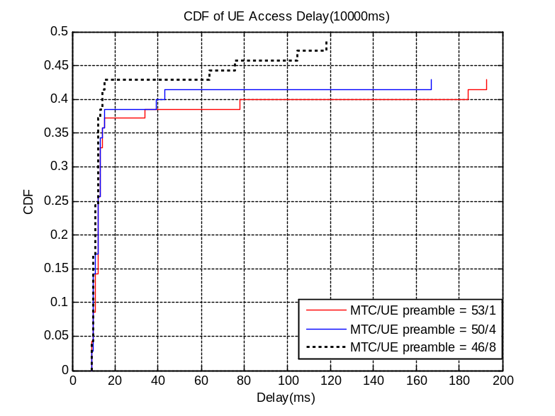
Figure 2.3-2 CDF of access delay - 10s case (UE)

UMTS
The simulation parameters are the same as defined in the paper on basic UMTS performance evaluation [2]. In this case, signature partition is applied. The same signature partition is configured in each PRACH. 2 cases of signature partitions are evaluated:
- signature partition of UE/MTC is 1/15
- signature partition of UE/MTC is 3/13
Note: only in the UMTS simulation, the CDF of access/packet delay is normalized to 1.

RACH performance

MTC RA attempts randomization period: 10 seconds
Table 2.3-2 shows the results for the 10s case:
 | signature partition of UE/MTC is 1/15 | signature partition of UE/MTC is 3/13
Collision rate | 9.73% | 9.11%
MTC Access Success probability | 24.86% | 24.79%
UE Access Success probability | 76.92% | 82.42%
Table 2.3-2. RACH performance (10 seconds spreading time)

Figure 2.3-3 shows the CDF of access delay of MDs(MTC Devices) and UEs:
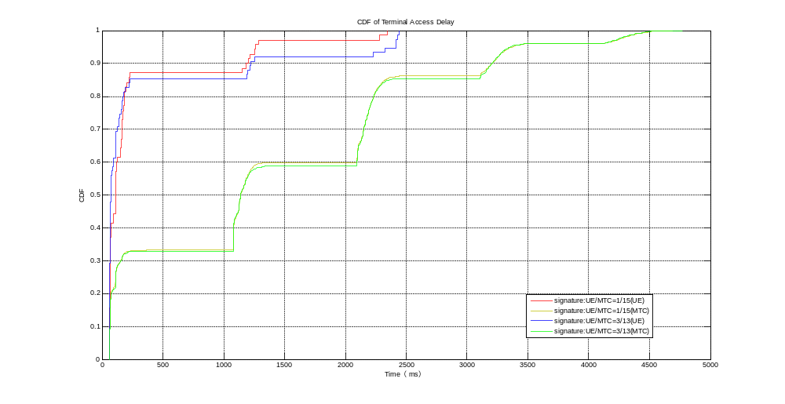
Figure 2.3-3 CDF of access delay - 10s case (UE and MTC)

MTC RA attempts randomization period: 60 seconds
Table 2.3-3 shows the results for the 60s case:
 | signature partition of UE/MTC is 1/15 | signature partition of UE/MTC is 3/13
Collision rate | 2.35% | 2.31%
MTC Access Success probability | 51.93% | 51.31%
UE Access Success probability | 74.14% | 77.59%
Table 2.3-3. RACH performance (60 seconds spreading time)

Figure 2.3-4 shows the CDF of access delay of MDs(MTC Devices) and UEs:
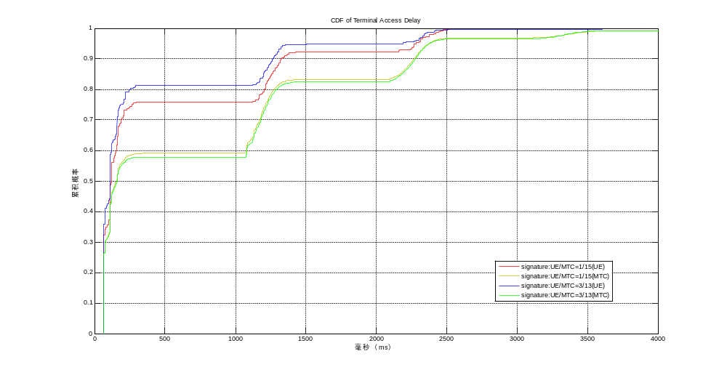
Figure 2.3-4 CDF of access delay - 60s case (UE and MTC)

MTC application level performance

MTC RA attempts randomization period: 10 seconds
Table 2.3-4 shows the results for the 10s case:
 | signature partition of UE/MTC is 1/15 | signature partition of UE/MTC is 3/13
Collision rate | 9.77% | 9.41%
MTC Access Success probability | 19.38% | 19.47%
UE Access Success probability | 88.57% | 75.24%
MTC Completion Success probability | 4.89% | 4.42%
Table 2.3-4. Application performance (10 seconds spreading time)

Figure 2.3-5 shows the CDF of application delay of MDs:
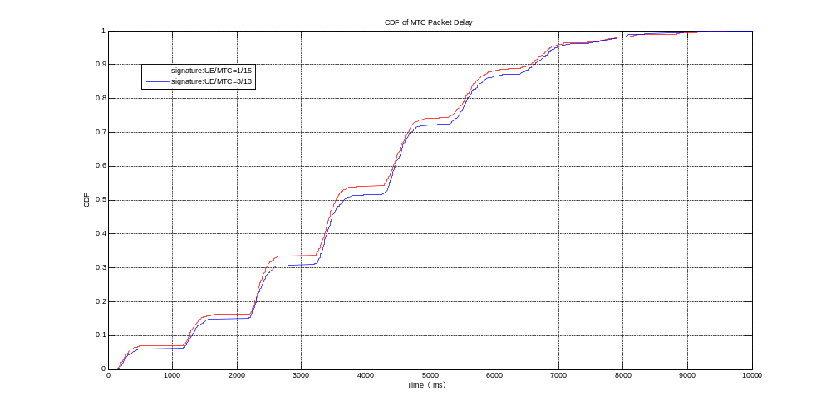
Figure 2.3-5 CDF of application delay - 10s case

MTC RA attempts randomization period: 60 seconds
Table 2.3-5 shows the results for the 60s case:
 | signature partition of UE/MTC is 1/15 | signature partition of UE/MTC is 3/13
Collision rate | 3.88% | 3.76%
MTC Access Success probability | 44.04% | 44.10%
UE Access Success probability | 71.18% | 62.72%
MTC Completion Success probability | 13.90% | 13.93%
Table 2.3-4. Application performance (10 seconds spreading time)

Figure 2.3-6 shows the CDF of application delay of MDs:
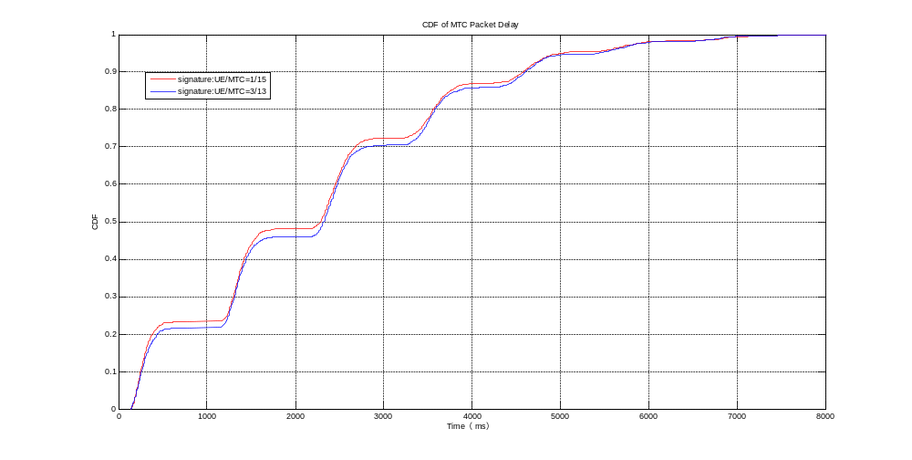
Figure 2.3-6 CDF of application delay - 60s case

Dynamic allocation of RACH resources
To simplify the simulations, instead of truly dynamically allocating additional RACH resources, three different cases of additions of further sub-frames for MTC dedicated access have been considered.
The following table lists the considered cases:
 | % of additional subframes for MTC dedicated access
case 1 | 0% (4 RACH subframes per SFN)
case 2 | 50% (6 RACH subframes per SFN)
case 3 | 100% (8 RACH subframes per SFN)
Table 2.4-1
Notes:
- When additional subframes for MTC dedicated access are added, UL resources used by PRACH (6PRBs) in these subframes are considered.
- Additional subframes are only for MTC access.
- Access success probability for UE and MTC devices are calculated separately.

RACH performance

MTC RA attempts randomization period: 10 seconds
Table 2.4-1 shows the results for the 10s case:
additional subframe for MTC dedicated access | 0% | 50% | 100%
Collision rate | 53.71% | 43.77% | 34.15%
MTC Access Success probability | 10.85% | 17.30% | 21.26%
UE Access Success probability | 40% | 44.29% | 42.86%
Table 2.4-1. RACH performance (10 seconds spreading time)

Figures 2.4-1 and 2.4-2 The CDF of access delay of MDs(MTC Devices) and UEs:
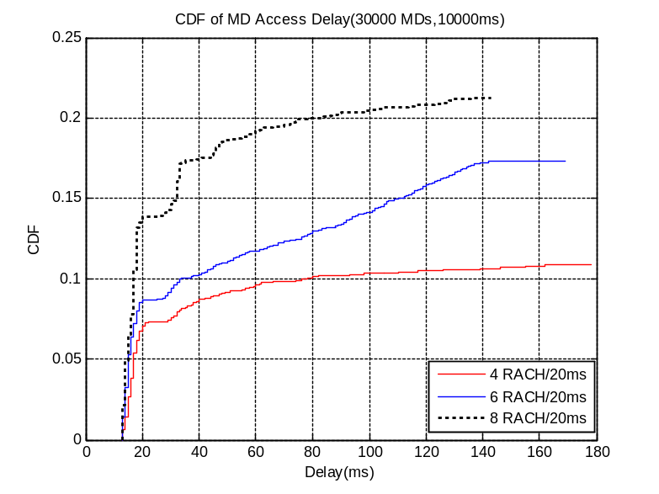
Figure 2.4-1 CDF of access delay - 10s case (MTC)

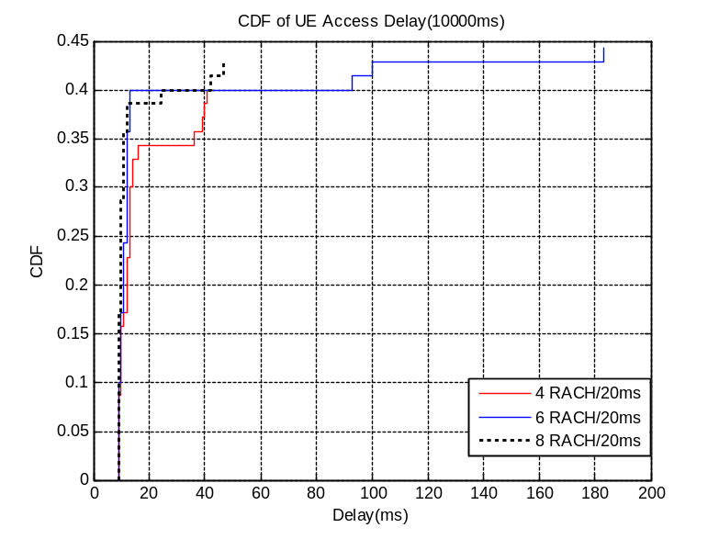
Figure 2.4-2 CDF of access delay - 10s case (UE)

MTC application level performance
Considering the limitations of PUSCH and PDSCH, only the ‘Low background traffic (non-MTC) load’ cases are simulated.

MTC RA attempts randomization period: 10 seconds
Table 2.4-2 shows the results for the 10s case:
additional subframe for MTC dedicated access | 50% | 100%
Collision probability | 47.65% | 34.07%
MTC Access Success probability | 11.47% | 13.88%
MTC Completion Success probability | 11.47% | 13.88%
UE Access Success probability | 55.71% | 68.57%
PDCCH Usage | 36.50% | 42.42%
PDSCH Usage | 12.35% | 14.88%
PUSCH Usage | 48.89% | 55.48%
Table 2.4-2. Application performance (10 seconds spreading time)

Note: for the performance of case 1 (0% additional subframes) please refer to [1].

The following Figures show the CDF of application delay of MDs and access delay of UEs:
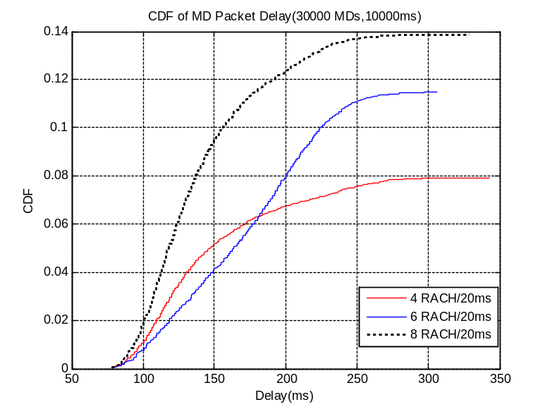
Figure 2.4-3 CDF of application delay - 10s case (MTC)
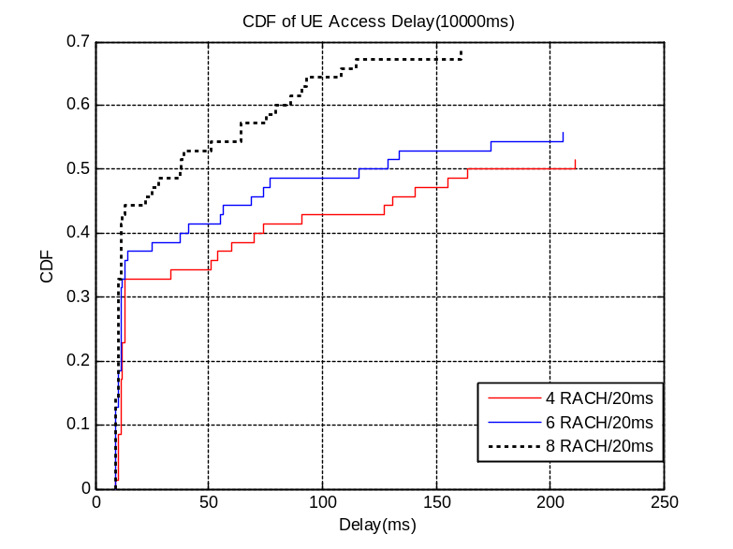
Figure 2.4-4 CDF of access delay - 10s case (UE)

MTC RA attempts randomization period: 60 seconds
Table 2.4-3 shows the results for the 60s case:
additional subframe for MTC dedicated access | 50% | 100%
Collision probability | 1.56% | 0.82%
MTC Access Success probability | 91.09% | 90.39%
MTC Completion Success probability | 91.09 % | 90.39%
UE Access Success probability | 100% | 100%
PDCCH Usage | 42.08% | 41.70%
PDSCH Usage | 16.29% | 16.13%
PUSCH Usage | 40.30% | 40.76%
Table 2.4-3. Application performance (60 seconds spreading time)

The following Figures show the CDF of application delay of MDs and access delay of UEs:
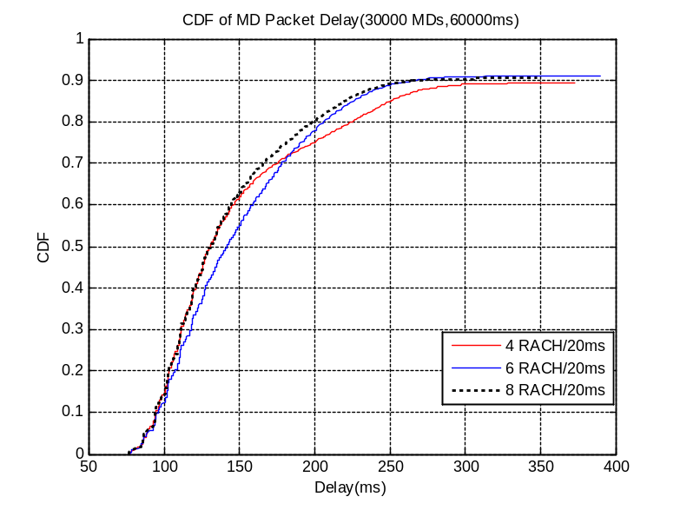
Figure 2.4-5 CDF of application delay - 60s case (MTC)
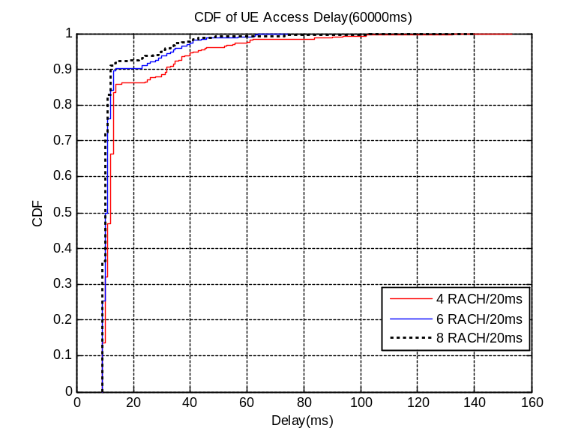
Figure 2.4-6 CDF of packet delay - 60s case (UE)

Analysis of results
From the above results, it could be concluded that:
- BO-based schemes
MTC specific backoff schemes do have some potential to improve the overall performance, but the improvement is not so high if the intensity of access arrivals is very high. For instance, the RACH performance (also for non-MTC devices) in case of 10s spreading time and high background traffic load (75% of system resources used by non-MTC devices) cannot achieve an acceptable level.
Backoff based schemes alone cannot protect the system and handle the massive simultaneous arrivals from MTC devices, but they can definitely provide some real improvements in some of the cases.
Obervation 1: BO-based schemes alone cannot resolve high RACH overload congestion, but they could provide some improvements in some cases (e.g. low RACH congestion level)
- ACB-based schemes
ACB based schemes can handle the overload to some extent, but if the congestion level is high (e.g. 30000 MTC devices in 10 second), also the ACB schemes – with the parameters considered so far - cannot spread the massive simultaneous arrivals efficiently enough.
Using large barring times and small barring factors, the MTC Access Success probability improves, although still not enough. At the same time, the access delay and the application delay of MTC devices are significantly increased (e.g. over 1 minute, or even over hundreds of seconds).
Further reducing the barring factor and increasing the barring time may bring further improvements. But clearly it will lead to even longer delays as well.
Obervation 2: ACB-based schemes can handle high RACH congestion levels, by setting extreme ACB values (i.e. very small barring factors and long barring times), although this would lead to very long access delay (even up to hundreds of seconds) which could not be accepted by some time-sensitive MTC applications. Furthermore, if RACH congestion happens in a very short time, ACB-based schemes can not always adjust the ACB configuration in time, due to the low response speed.
- Separate RACH resources
  - LTE
Comparing with “no separate RACH” case, separate RACH schemes can reduce the impact on non-MTC UEs when in high RACH congestion level case, and slightly reduce the MTC performance.
However, they still cannot improve the UE performance to a satisfactory level when in a high RACH congestion case, also due to PDCCH limitations.
  - UMTS
Separate signature schemes cannot effectively reduce the impact on non-MTC UEs, also in low congestion cases (e.g. 60s case)
Obervation 3: Separate RACH schemes do help to reduce the impact on non-MTC UEs, but the improvement is limited in high congestion level cases. Furthermore, MTC performance is typically worsened.
- Dynamic allocation of RACH resources
Allocating additional RACH resources is beneficial for resolving RACH congestion. Even considering the impact on the application level (due to PDCCH and PUSCH limitations), the MTC performance is improved and there is no bad influence to other indicators.
Considering that additional RACH resources will occupy more PUSCH resources, it should be possible to add them in a dynamic way (e.g. based on the RACH congestion level and overall traffic load). The drawback is that the improvement will be reduced in high traffic load cases.
Obervation 4: Dynamic allocation of RACH resources can be used in most of the cases, improving the MTC performance and not impacting other indicators, at least when the PUSCH resource is not overloaded.

Conclusion & Proposal
In order to derive some conclusions, it should be noted that in most situations it’s reasonable for the network to configure relatively low access control parameters (e.g. ACB may be even shut off) in order to maintain the system efficiency when the RACH congestion level is low.
Then, when a huge number of MTC devices try to access the network more or less at the same time, the RACH load will start to increase from a low level to a high level. The load increase will typically span over several seconds. During this time period (before reaching the highest congestion level) only dynamic RACH allocation schemes can timely increase the RACH resources, based on the speed of the RACH congestion level growth, and ensure that the system still has a high efficiency.
If the network detects that the RACH congestion level has reached a certain threshold that dynamic RACH allocation schemes cannot further handle, other time spreading schemes could be activated to reduce the intensity of access arrivals.
Therefore, considering the need to ensure the system efficiency, it’s proposed to select the dynamic RACH allocation scheme as the basic solution to address RACH overload, and possibly other schemes (e.g. BO-based and/or ACB-based) as supplementary solutions.
Proposal 1: dynamic RACH allocation schemes, allocating additional RACH resources only for MTC devices, should be considered as the basic solution to address RACH overload in case of MTC traffic
Proposal 2: time spreading schemes (e.g. BO-based and/or ACB-based) could be considered as supplementary solutions.

References
- R2-104663 [70bis#11] - LTE: MTC LTE simulations, ZTE
- R2-104661 MTC UMTS simulation results

